**פתרון תרגילים מחוברת תרגילים**

**פרק 23 - Backup and Recovery**

1.

BACKUP DATABASE [eDate]

TO DISK = N'D:\DBA\Backups\edate.bak' WITH NOFORMAT, NOINIT,

NAME = N'eDate-Full Database Backup', SKIP, NOREWIND, NOUNLOAD, STATS = 10

GO

2.

insert into Operation.Members (Username,Password,FirstName,LastName,CountryId,EmailAddress,GenderId,BirthDate,RegistrationDateTime)

values('vika278','123123','Vika','O',1,'viktoria2708@gmail.com',2,GETDATE(),GETDATE())

3.

BACKUP DATABASE [eDate]

TO DISK = N'D:\DBA\Backups\edate.bak' WITH DIFFERENTIAL, NOFORMAT, NOINIT,

NAME = N'eDate-Full Database Backup', SKIP, NOREWIND, NOUNLOAD, STATS = 10

GO

4.

insert into Operation.Members (Username,Password,FirstName,LastName,CountryId,EmailAddress,GenderId,BirthDate,RegistrationDateTime)

values('lena137','123123','Lena','O',1,'viktoria2708@gmail.com',2,GETDATE(),GETDATE())

5. After changing the recovery model of the eDate DB from SIMPLE to FULL, run the following script:

BACKUP LOG [eDate]

TO DISK = N'D:\DBA\Backups\edate.trn' WITH NOFORMAT, NOINIT,

NAME = N'eDate-Full Database Backup', SKIP, NOREWIND, NOUNLOAD, STATS = 10

GO

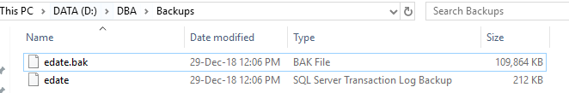

6.

insert into Operation.Members (Username,Password,FirstName,LastName,CountryId,EmailAddress,GenderId,BirthDate,RegistrationDateTime)

values('israel','123123','Israel','Israeli',1,'ii@gmail.com',1,GETDATE(),GETDATE())

7. Disconnect from DB and then run the following script:

USE [master]

RESTORE DATABASE [eDate]

FROM DISK = N'D:\DBA\Backups\edate.bak' WITH FILE = 1,

NORECOVERY, NOUNLOAD, REPLACE, STATS = 10

GO

8.There is no access to DB that was restored with no recovery.

9.

USE [master]

RESTORE DATABASE [eDate]

FROM DISK = N'D:\DBA\Backups\edate.bak' WITH FILE = 1,

STANDBY = N'C:\Program Files\Microsoft SQL Server\MSSQL14.MSSQLSERVER\MSSQL\Backup\eDate_RollbackUndo_2018-12-29_12-19-06.bak',

NOUNLOAD, STATS = 10

GO

10.There are 100001 members (including the new member from the first insert).

DB in standby mode is for read only, no more rows can be inserted.

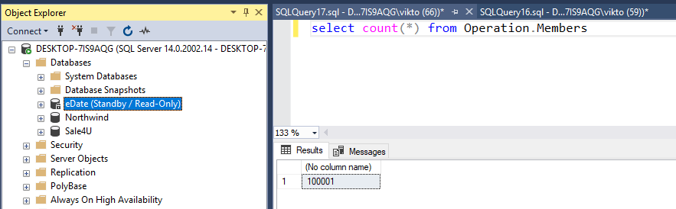

11.

USE [master]

RESTORE LOG [eDate]

FROM DISK = N'D:\DBA\Backups\edate.trn' WITH FILE = 1,

STANDBY = N'C:\Program Files\Microsoft SQL Server\MSSQL14.MSSQLSERVER\MSSQL\Backup\eDate_RollbackUndo_2018-12-29_12-24-28.bak',

NOUNLOAD, STATS = 10

GO

12. There are 100002 members (including the member from the second insert)

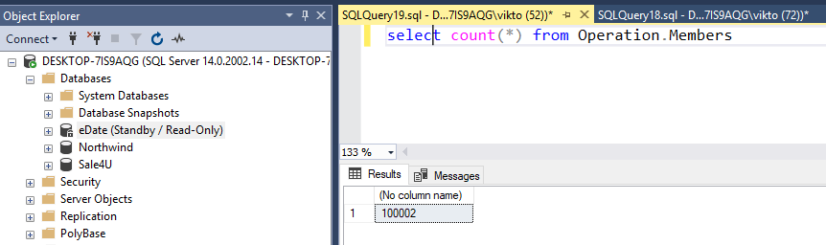

13. To bring DB online from standby mode, close all open sessions and run the following script:

USE [master]

restore database eDate with recovery

14.

CREATE DATABASE eDate_Snapshot_1_00 ON

(Name='eDate_Data', Filename='D:\DBA\CourseMaterials\eDate\SnapExample1.SS')

AS SNAPSHOT OF eDate

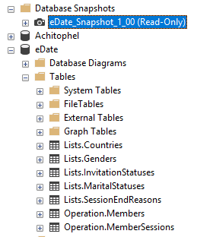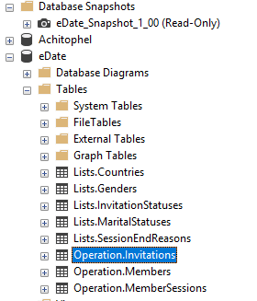GO

drop table Operation.Invitations

Disconnect all sessions from the DB and then

run the script:

USE MASTER

GO

RESTORE DATABASE eDate

from DATABASE_SNAPSHOT='eDate_Snapshot_1_00'

GO

**Log Shipping:**

I have created another instance on my local computer to simulate another server.

On the primary instance I defined the settings for log shipping.

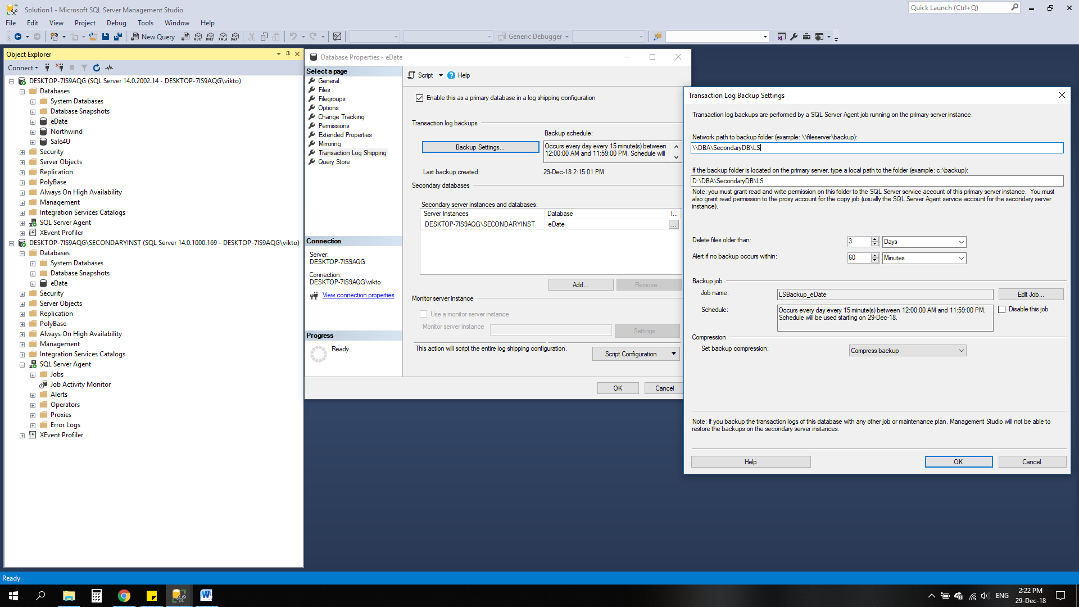

Definition of the secondary DB:

